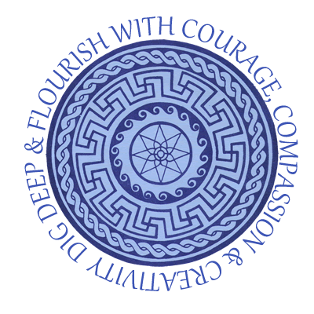

Intent, Implementation and Impact of Writing at Sparsholt C of E Primary School
Writing Intent:

At Sparsholt we believe that all pupils should be taught how to confidently communicate their knowledge, ideas and emotions through their writing so that they can use this essential skill as they move through life.

We want pupils to acquire a wide vocabulary, a solid understanding of grammar and be able to spell new words by effectively applying the spelling patterns and rules they learn throughout their time in primary school. We want them to write clearly, accurately and coherently, adapting their language and style in and for a range of contexts, purposes and audiences. It is therefore our aim to create a writing curriculum that is both aspirational and responsive to the children’s needs using high quality text drivers as models for writing and to inspire and motivate children so that they have a clear understanding about the power of writing.

Writing Implementation:

At Sparsholt we use high quality stimuli to engage and inspire writing. These could be short or longer texts, animations, poetry etc. (see: ‘English Long Term Overview)
These are used to drive learning journeys toward written outcomes which enrich our pupils’ store of knowledge, allow them to creatively imitate great writers, be inspired to write by interesting themes and build strong links between reading and writing.
Our learning journey approach is developed through three stages:

- ‘Stimulate and generate’ which allows for immersion in a text/stimulus, pupil response and the teaching of vocabulary (‘reading as a reader’). Working Walls are used to record these responses so that they can be utilised in the writing process.

- The ‘capture, sift and sort’ stage moves to the analysis of text, and the direct teaching of grammar in context (‘reading as a writer’). Shorter pieces allow pupils to rehearse these skills and receive feedback.

- The final stage of ‘create, refine and evaluate’ sees the pupils crafting writing to be proud of.

- Throughout, site of application pieces or ‘drop in’ writes allow for the application of knowledge and skills taught in previous learning journeys, ‘interrupting the forgetting’. These can also be used in other areas of the curriculum.

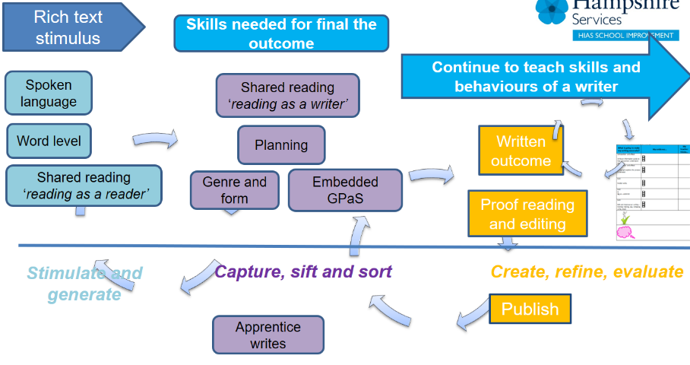

Planning and Teaching:
- Our learning journeys are inspired by high quality texts/stimuli that we as a school feel will motivate our children to want to write, give purpose to their writing and will provide children the opportunity to widen their understanding of the World and give them an insight into the experiences and issues that may affect those with different backgrounds to their own. Some of these are linked to our topic themes but others are chosen because of their value in ensuring children have access to a variety of motivating texts from across the ages.

- Teachers plan suitable writing outcomes that will provide children the opportunity to apply writing skills suitable for their age and stage. Purpose and audience are key. Our writing Learning journeys for units of work are planned in a sequence to develop prior knowledge and ensure there is a clear progression of skills. We use the Hampshire Writing progression documents to help plan objectives for the writing outcomes. We teach English as whole class lessons, so that all children have access to the age-related skills and knowledge contained in the National Curriculum. Within lessons, teachers and teaching assistants target support for slower graspers to enable them to achieve at an age-related level wherever possible. This may involve a greater level of scaffolding and access to additional support materials such as Word Banks or a greater level of modelling. Rapid graspers are given opportunities to extend their writing in a variety of ways, including through showing greater control in their writing, a deeper understanding of the impact that their writing has on the reader and by using a higher level of vocabulary and grammar features.

- Spelling, grammar and punctuation teaching is interwoven into the learning journey so that pupils can utilise the necessary tools to make their writing powerful and moving for the reader. The Hampshire Spelling, Grammar and punctuation progression documents are used to plan the teaching of relevant skills for each year group. The school follows the ‘No Nonsense’ Spelling program which focuses on spelling rules and patterns. Children are encouraged to apply taught spelling and grammar rules whenever they write in all areas of the curriculum.

- During the writing process, teachers will regularly allow children the opportunity to review their work either independently, in small groups or in a wholes class setting. As a school, we try to encourage and build independent learners who are motivated to improve. We place a lot of emphasis on ensuring children develop independence in being able to identify their own areas for improvement in all pieces of writing, editing their work effectively during and after the writing process. We therefore encourage all children to self-edit prior to direct teacher intervention and then again after direct teacher intervention. Direct teacher intervention will involve teachers marking a piece after it is completed and identifying areas of improvement for that specific piece. Children will then be asked to make those improvements to that piece using a purple pen where appropriate for age and stage.

- Each child has individualised writing targets set that they need to ensure they try to achieve during the writing purpose. These targets are areas that children need to ensure they master to allow them to continue to make progress with their writing (they may be a prior year group writing objective that a child has not managed to embed). Children will be given opportunities to practise these prior to writing and support to ensure they achieve them. Where it becomes obvious that a child is not achieving their writing target, additional 1:1 support sessions will be undertaken.

- All pupils should be encouraged to take pride in the presentation of their writing, in part by developing a good, joined, handwriting style by the time they move to secondary school. A whole school approach for handwriting using the ‘Letter join’ resources is aimed at children progressing towards a cursive style and being able to write smoothly, legibly and neatly.

SEN Support
In addition to support within the classroom setting, we also undertake the following to support children with SEND needs:
- Precision teaching (writing and spelling intervention)
- Toe to Toe – spelling intervention.
- Narrative sequencing

Assessment
Teachers will use their professional judgement to determine whether a child is working within age-related expectations, working at greater depth or working below. They will base their judgements on the quality of the extended write that pupils produce independently, and determine to what extent pupils have met the agreed success criteria for writing outcomes. Teacher’s will use the Hampshire progression documents, exemplification materials and moderation events as a support for making judgements, to inform planning and to provide additional provision to ensure children make good progress from their starting points.

Parental engagement
Parents are encouraged to support children with their phonic and spelling development.

Writing Impact

- Pupils enjoy and take pride in their writing, and can adapt their writing for a range of purposes and audiences
- Children are confident and competent writers with increased stamina.
- The school environment reflects a love of writing.
- Clear progression is evident and writing outcomes progress in lessons and over time.
- Staff have a clear understanding of their children’s writing attainment and are confident to plan lessons to move their learning on.
- Writing opportunities are fully embedded in every opportunity across the curriculum.
- Pupils have a wide vocabulary that they use within their writing
- Pupils will leave primary school being able to effectively apply spelling rules and patterns they have been taught including applying phonics and spelling strategies.
- Parents and carers will have a good understanding of how they can support spelling, grammar and composition at home, and contribute regularly to homework
- The % of pupils working at ARE within each year group are at least in line with Hampshire and National averages.
- The % of pupils working at Greater Depth within each year group are at least in line with Hampshire and National averages
- Learners are well prepared for their next stage of education.

